**WORK INSTRUCTIONS FOR REFRACTORY GUNNING (ROBOTIC) INSIDE FURNACE**

**Responsibility:** Head – Pig Iron Division

HOD Production,

Blast Furnace Incharge,

Refractory Engineer, Supervisors & Workmen

* Objective : - Gunning on existing refractory/shell inside furnace to enhance Campaign Life and Reduce heat Loss
* Scope : - Blast furnace
* Ref. : - Blast Furnace Drawings, Safety Standards,

Reference from Other steel plants

**PPE to be used** : Helmet, Safety shoes, Hand gloves, Safety

Goggles, Safety Belts, CO Detector, Dust Mask, earmuffs whenever required.

* Activity No 1 : Metal jam/ skull/ Remaining bricks /slag coating cleaning inside the furnace.
* Activity 2 : Pressure testing and replacement of cooling plate if cooling plate found leaking.
* Activity No 3 : Fitting& Removal of Gunning POD, Hoses, Slings& Gunning Operation
* Activity No 4 : Refractory work, welding work to close the window area (after Gunning)

**Aspect- Impact**

|  |  |
| --- | --- |
| Scrap generation | : Resource depletion |
| Spillage of carbon mass | : Land contamination |
| Fire | : Air pollution, resource depletion |
| Oil leakage | : Land contamination |

**Hazards identified**

**Mechanical Hazard:**

1. Fall of object, tools & tackles, Refractory material from Height.
2. Fall of objects due to Failure of electrical winch, wire rope, slings etc.
3. Trapping/Entanglement of person in rotating parts, hoses, wire rope, electrical cables & slings etc.
4. Impact of material, machinery, crane hook etc.
5. Fall of hazardous material in eyes / body.
6. Fall of person from height.
7. Hit by material during shifting of materials.

**Physical hazard:**

1. Dust inhalation.
2. Burn injury during welding
3. Splashing of liquid binder, resin in eyes
4. Fire.
5. Slippage of hose from air pressure clamps
6. Noise of compressor, drill machine, vibrator
7. Darkness.
8. Slippage of legs.
9. Congestion.
10. Suffocation.
11. BF Gas poisoning.

**Electrical Hazard:**

1. Electric shock.
2. Shot circuit.

**Behavioral Hazard:**

1. Human Behaviour -Workmen under influence of alcohol
2. Human Behaviour -Violation of procedure
3. Human Behaviour -Not wearing PPE’s
4. Human Behaviour -Not concentrating while operating machine
5. Human Behaviour -Ignorance/casual approach

**Activity 1: Metal jam/ skull/ slag coating cleaning**

1. After blowing down of Furnace take the furnace shutdown as per normal standard shutdown procedure. Please follow WI/PROD/06-BRev 9 for the same.
2. Steam purge the whole GCS.
3. Open all the flanges for air purging in GCS after isolating and steam purging.
4. Gas cleaning is to be isolated by putting blank after the cyclone.
5. Remove all blow pipes, tuyeres.
6. Blank blow pipe openings in the bustle.
7. Start raking coke from the furnace after making arrangement of temporary trough in front of all tuyere openings. two CO monitors to be carried during coke raking.
8. Inspection to be done from furnace top hatch for presence of metal jam/ slag coating/ refractory inside furnace. Two CO monitors to be carried during inspection.
9. If there is any metal jam/ slag coating observed, the same need to be clear from outside furnace by cutting pocket in furnace shell. No manpower shall be allowed to enter inside furnace under any circumstances or entire operation. All jobs shall be executed from outside of furnace.
10. The metal jam/ slag coating to be removed from pocket area by hammering/ breaker, and can be thrown inside furnace, which can later be taken out from tuyer opening. Care has to be taken to avoid falling of jams/bricks directly on to cooling plate.
11. While doing the above cleaning activity, no persons shall be allowed to stand/ work in front of tuyere openings. All tuyere shall be blanked with metallic sheets.
12. Platform shall be made at the particular area wherever pocket need to cut, if there is no platform.
13. After completion of above activity, all fallen metal jam/ slag coating at hearth shall be removed from Tuyer area by pocking rods / by cutting with the help of lancing operation During lancing operation No work should be carried out on furnace top, Bleeder and GCS. Nobody should be allowed in the said area.
14. All scrap need to be shifted to the designated area. For scrap shifting please refer *WI/MAINT/12*.
15. Use all necessary PPEs.
16. Hot Blast stoves to be heated during gunning operation with BFG or Diesel if BFG is not available.

**Activity 2: Pressure testing and replacement of cooling plate if cooling plate found leaking.**

1. During process of skull removal/ remaining brick removal / cleaning, there will be chances of falling of above said material. So, it is better to check or ensure all the cooling plate are not damaged. So, before gunning, pressure testing of cooling plate is necessary. Please follow work instruction for cooling plate pressure testing. WI/PROD/54. If any plate is found leaking, please replace that particular cooling plate immediately.

**Activity 3: Fitting& Removal of Gunning POD, Hoses, Slings& Gunning Operation**

1. The gunning will be carried out by Blast Furnace Robotic gunning equipment. This Gunning equipment has a very high nozzle pressure which gives a very solid and compact gunned lining.

For gunning inside the Blast furnace temperature should below 200˚C to prevent any damage to the robotic gunning equipment. Also prior to the above it is to be ensured there is no CO presence in the furnace after CAPING of the furnace burden.

1. For Capping, granulated slag of 400-500 mm thick can be put on burden in order to cap the burden to reduce the inside temperature of blast furnace and CO emission. Capping can also be done by low quality aluminous gunning material in absence of granulated slag. After CAPING the furnace burden with slag or with Capping material, all tuyere openings should be closed with plate.
2. All tools, tackles and machineries which will be used for gunning operation should be certified by industrial act.
3. All tools, lifting equipment, gunning POD, lance etc. shall be taken to the respective platform by Furnace Top 5 Ton Hoist.
4. Three hanging Winch machine shall be fitted on Furnace Top Crown ring platform; two nos above two manholes and third one above any suitable top spray opening. Necessary supporting structure shall be erected if required to hang the winch machine.
5. Slings/Chains shall be dropped through openings and shall be taken out through the cut portion of upper stack to fit the gunning lance, POD, hoses & halogens.
6. Removable hand railing shall be made with poking rods in the cut area of upper stack as barricading purpose. The railing shall be projected inside so that gunning operator can better look inside furnace.
7. The gunning machines, mixer machine, booster pump and air compressor, pre-dampener and the material to be gunned will be installed in BF 2 Glendon area.
8. For mixing gunning material in mixer, follow WI/MAINT/67.
9. 3 Ton EOT Crane / 15MT or 25MT Hydra in BF 2 Glendon area shall be used for lifting gunning material bags for mixing purpose.
10. For shifting all materials/ equipment, follow WI/MAINT/12.
11. Before commencing gunning, the refractory/ shell wall shall be washed with high pressure air with some water from top to bottom.
12. Gunning shall be start from bottom by lowering the POD assembly by sling/ chains from winch machine.
13. Uniform refractory profile shall be made by gunning. It has been proposed to build up a thickness of 150 – 200 mm over residual lining present. But, the final lining profile has to be discussed after furnace shutdown depending upon the wear pattern of the existing refractory and availability of material.
14. Gunning to be continued on and above window area by lifting the gunning pod as high as possible to cover maximum possible area, leaving the cut area.
15. The gunning material shall be conveyed through material hose from the gunning machine to gunning nozzle with compressed air.
16. All tools, tackles, Hoses, Cables and Equipment should be as per industrial safety standard and should be certified.
17. Persons conducting the gunning operation at upper stack platform, persons controlling the winch machines and the persons performing the mixing operation at ground level should have walky-talky for contact all the time.
18. During gunning, rebounded material shall be removed from tuyere with concurrence/co-ordination with the gunning persons.
19. On completion of the gunning operation, the gunning POD assembly shall be raised to the access door at upper stack and all the services shall be disconnected. The POD shall be removed from the furnace and the chain hoists shall be removed.

Gunning Pics

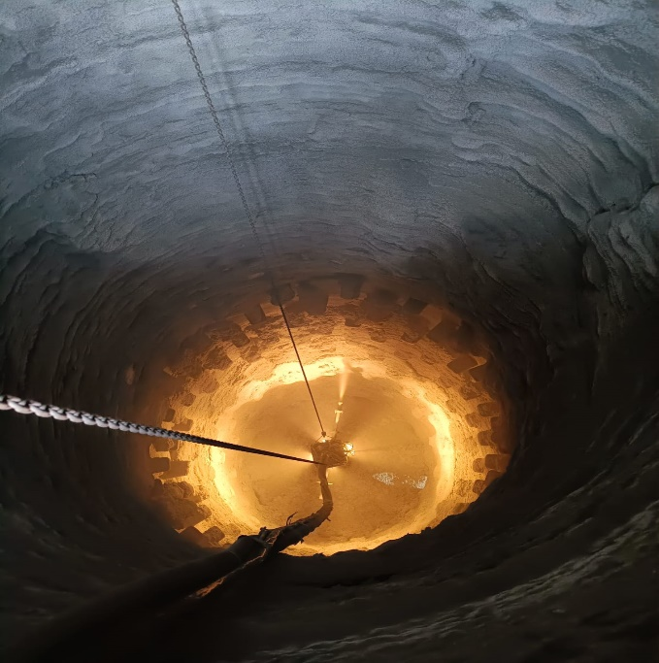 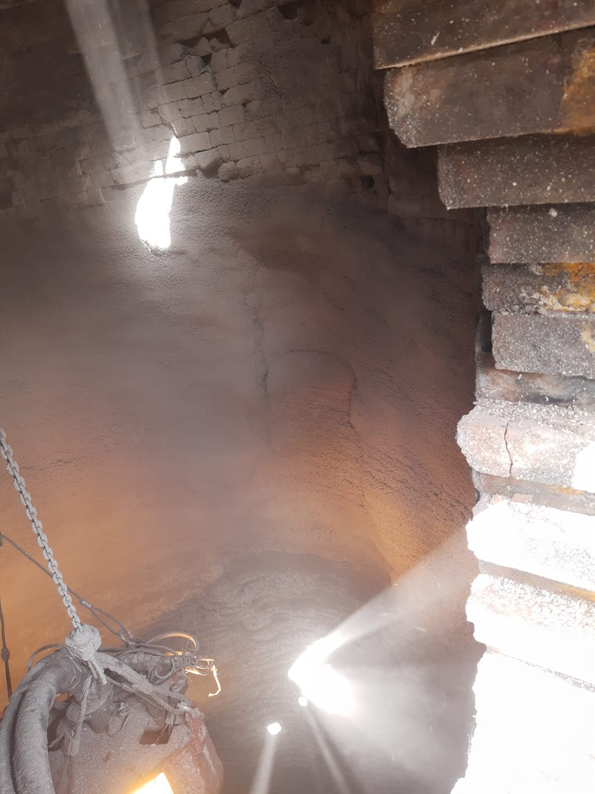

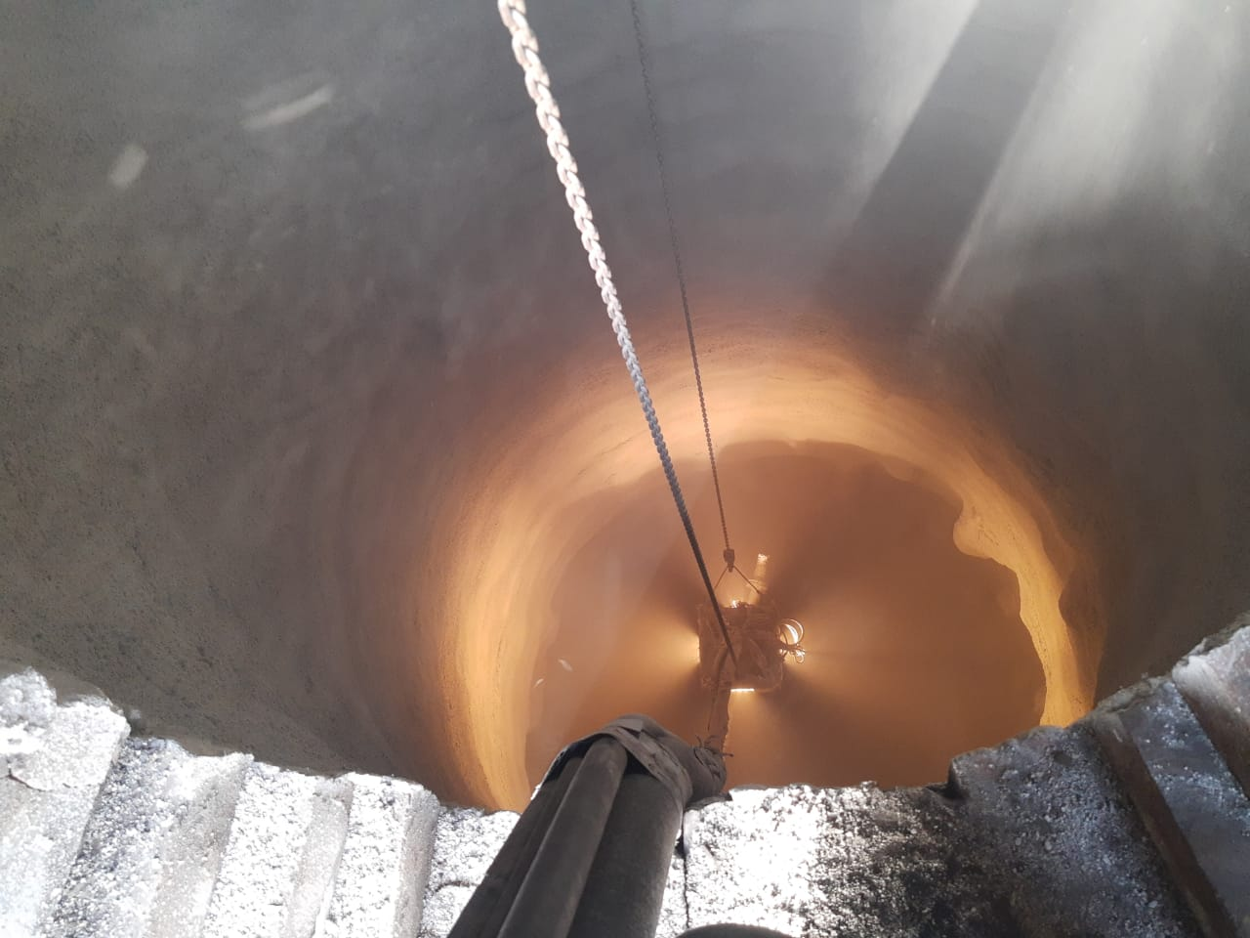

General arrangement of BF2 refractory lining (2014) with additional cooling plates



**Activity No 4 : Refractory work to close window area (after Gunning)**

1. The shell to close cut area shall be casted with cast able & anchors separately, and shall be fitted after taking out all gunning pod and hoses etc. High Alumina Conventional Cast able can be used for the above purpose.

|  |  |  |
| --- | --- | --- |
| **Prepared By:**  Head – Production PID I | **Reviewed & Issued By:**  Management Representative | **Approved By:**  Head – Pig Iron Division |
| **Signature:** | **Signature:** | **Signature:** |
| **Date: 15.07.2022** | **Date: 15.07.2022** | **Date: 15.07.2022** |

|  |  |  |  |
| --- | --- | --- | --- |
| **Amendment Record** | | | |
| **Revision date** | **Manual Section ref. and para** | **Brief details of revision** | **New Revision No.** |
| 15.07.2022 | Activity 3: Fitting& Removal of Gunning POD,Hoses,Slings& Gunning Operation  Change in format  General arrangement of BF2 refractory lining (2014) with additional cooling plates drawing added |  | 04 |
| 15.07.2022 | Gunning Pics added |  | 04 |